FSD ASSIGNMENT-1

Exercise 1: Basic HTML5 Structure

<!DOCTYPE html>

<html lang="en">

<head>

<meta charset="UTF-8">

<title>My First HTML Page </title>

</head>

<body>

<h1> Keerthi M S</h1>

<p> I love reading books and cooking </p>

<hr>

<br>

</body>

</html>

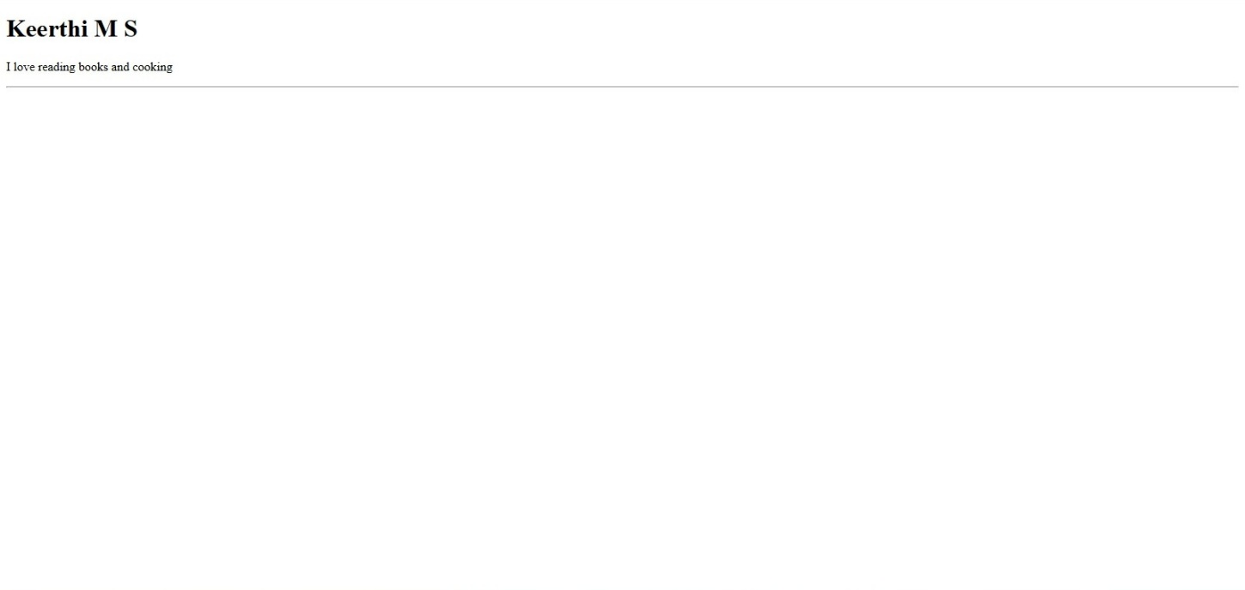

Exercise 2: Use of Lists and Links

<!DOCTYPE html>

<html lang="en">

<head>

<meta charset="UTF-8">

<title>Use of Lists and Links</title>

</head>

<body>

<h1> Favourite Fruits </h1>

<ul>

<li> Mango </li>

<li> Guava </li>

<li> Orange </li>

</ul>

<h2> Movies </h2>

<ol>

<li> Kantara </li>

<li> KGF </li>

<li> Mussanje Maathu </li>

</ol>

<a href="https://www.htmlexample.com" target="_blank"> My Webiste</a>

</body>

</html>

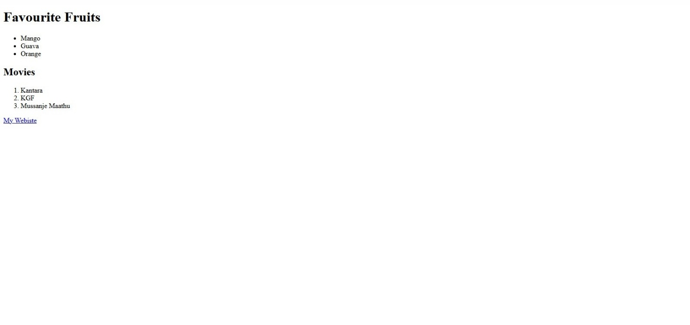

Exercise 3: Adding Images and Tables

<!DOCTYPE html>

<html lang="en">

<head>

<meta charset="UTF-8">

<title>Adding Images and Tables</title>

</head>

<body>

<h2>My Favorite Image</h2>

<img src="https://www.cre8iveskill.com/upload/images/product/happy-baby-mini-mouse.jpg"style="width:300px; height:200px;">

<h2>Student Details</h2>

<table border="2">

<tr>

<th>Student Name</th>

<th>Age</th>

<th>Favorite Subject</th>

</tr>

<tr>

<td>Aarthi</td>

<td>20</td>

<td>Advanced DBMS</td>

</tr>

<tr>

<td>Varsha</td>

<td>21</td>

<td>Artificial Intelligence</td>

</tr>

<tr>

<td>Kavya</td>

<td>22</td>

<td>Data Science</td>

</tr>

</table>

</body>

</html>

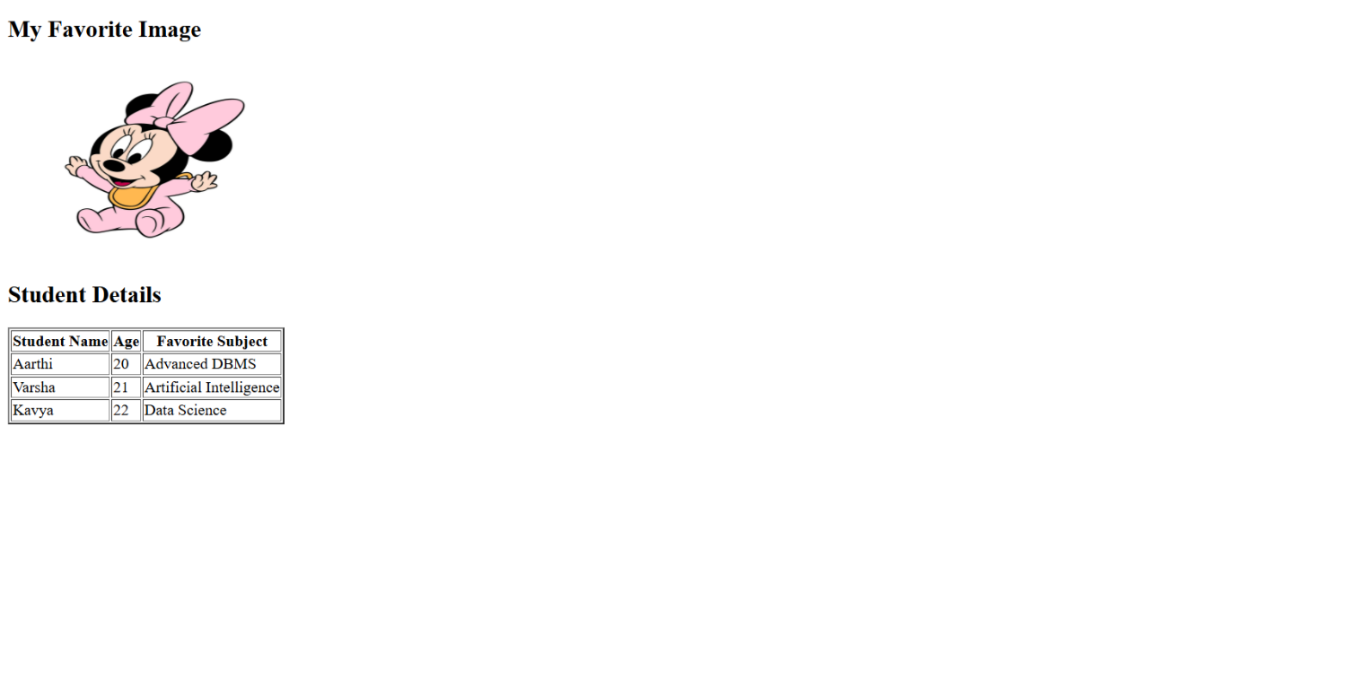

Exercise 4: Introduction to CSS (Internal CSS)

<!DOCTYPE html>

<html lang="en">

<head>

<meta charset="UTF-8">

<title>Introduction to CSS</title>

<style>

h3{

background-color: lightblue;

color: darkblue;

font-size: 30px;

}

p {

font-family: Arial;

text-align: justify;

}

</style>

</head>

<body>

<h3>My Favourite Hobbies</h3>

<p> I love reading books and Cooking </p>

</body>

</html>

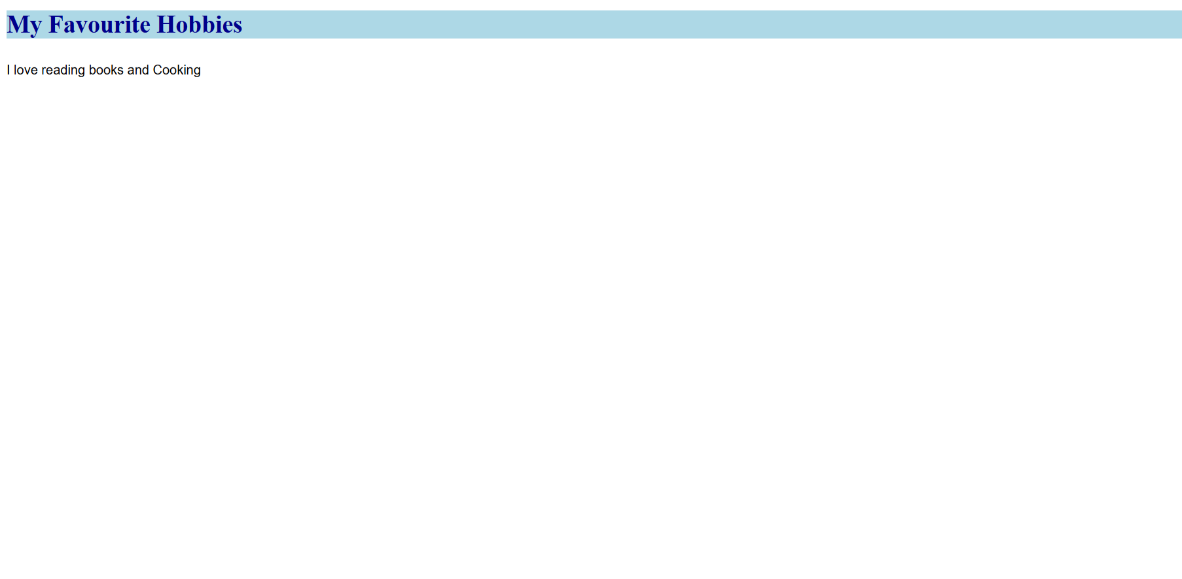

Exercise 5: CSS Classes and IDs

!DOCTYPE html>

<html lang="en">

<head>

<meta charset="UTF-8">

<title>CSS Classes and IDs</title>

<style>

#intro {

border: 2px solid black;

padding: 10px;

}

.highlight {

background-color: yellow;

}

</style>

</head>

<body>

<div id="intro">

Riya is reading a book at the library.

</div>

<div class="highlight">

Full Stack Development class will start at 9 AM.

</div>

</body>

</html>

